SESSION 1: NETWORK TOPOLOGIES
Network topology refers to the physical or logical arrangement of nodes (devices like computers or routers) and the connections between them in a network.
1. Bus Topology
All devices are connected to a single shared cable. Data travels along the cable, and each device checks whether the data is meant for it.
Advantages
- Simple and cost-effective
- Suitable for small networks
Disadvantages
- Poor scalability
- Failure of main cable disrupts the entire network
Uses
- Older Ethernet networks
- Small file or printer sharing setups
- Industrial sensor and controller networks
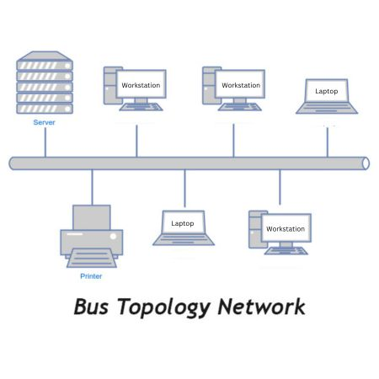
2. Star Topology
Each device connects to a central hub or switch, and all communication passes through it.
Advantages
- Easy installation and troubleshooting
- Failure of one device does not affect others
Disadvantages
- Central device failure brings down the network
- Requires more cabling
Uses
- Corporate networks
- Banking systems and ATMs
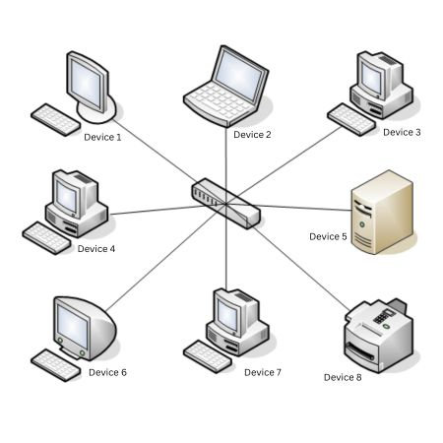
3. Ring Topology
Devices are connected in a closed loop, and data flows in one direction around the ring.
Advantages
- Equal access to network
- Predictable data flow
Disadvantages
- Single break disrupts the network
- Difficult to add or remove devices
Uses
- Token Ring LANs
- City-wide network loops
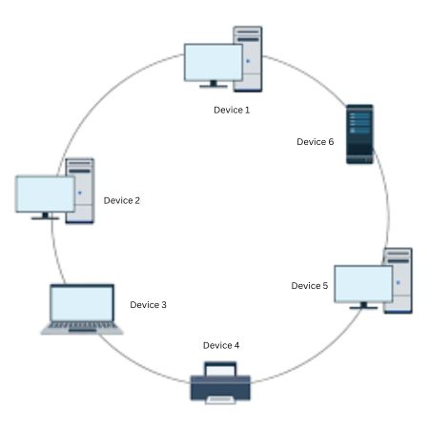
4. Mesh Topology
Each device connects to multiple or all other devices, providing multiple paths for data.
Advantages
- High reliability and fault tolerance
- No single point of failure
Disadvantages
- Expensive
- Complex installation and maintenance
Uses
- Military and battlefield networks
- Large-scale wireless networks
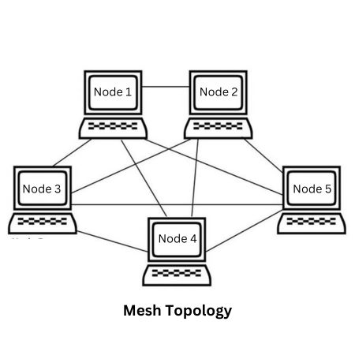
5. Hybrid Topology
Combination of two or more topologies to leverage their strengths.
Advantages
- Flexible and reliable
- Improved fault tolerance
Disadvantages
- Complex design
- Requires careful planning
Uses
- Data centers
- Hospital and enterprise networks
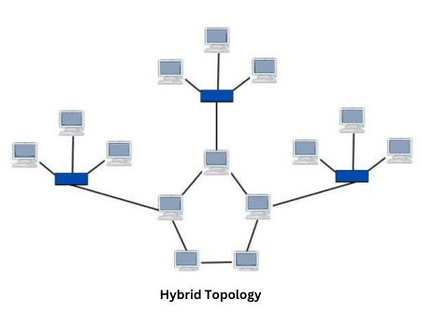
What is the Best Type of Network Topology?
Here are the best types of network topologies on different performance factors:
1. For low costs: Bus and Star
2. For high reliability: Mesh and Hybrid
3. For high scalability: Tree and Mesh
4. For high performance: Mesh and Star

Real-World Applications of Network Topologies
● Home Networks: Star topology is widely used in home setups where all devices connect to a central router for easy management and troubleshooting.
● Large Enterprises: Tree topology is ideal for large organizations with hierarchical departments, allowing scalable and structured connectivity.
● Data Centers: Hybrid topology is used in modern data centers to combine star and mesh for flexibility, redundancy, and high performance.

SESSION 2: Network Devices

Introduction
Network devices are hardware components used to connect, control, and manage data flow in a computer network. Each device operates at specific OSI layers and performs distinct functions.

1. Hub
Description
A hub is a basic networking device that connects multiple devices in a network and broadcasts data to all connected ports.
- Operates at Physical Layer (Layer 1)
- Does not filter traffic
Features
- No intelligence
- Same data sent to all devices
Limitations
- High collision rate
- Low security and performance

2. Switch
Description
A switch connects devices within a LAN and forwards data only to the intended recipient using MAC addresses.
- Operates at Data Link Layer (Layer 2)
Features
- Reduces collisions
- Improves performance
- Maintains MAC address table

3. Bridge
Description
A bridge connects two or more LAN segments and filters traffic using MAC addresses.
- Operates at Layer 2
- Predecessor of switches
Features
- Reduces network congestion
- Divides collision domains

4. Router
Description
A router connects different networks and routes data packets using IP addresses.
- Operates at Network Layer (Layer 3)
Features
- Uses routing tables
- Separates broadcast domains
- Supports routing protocols

5. Gateway
Description
A gateway connects networks using different protocols and performs protocol conversion.
- Operates across multiple OSI layers
Features
- Acts as entry/exit point
- Commonly used in enterprise networks

Layer 2 vs Layer 3 Switches
Layer 2 Switch
- Uses MAC addresses
- Performs switching within LAN
- No routing capability
Layer 3 Switch
- Uses MAC + IP addresses
- Performs switching and routing
- Faster than routers for LAN routing

Comparison Table
Device | OSI Layer | Address Used | Function
Hub | Layer 1 | None | Broadcast data
Bridge | Layer 2 | MAC | Filter traffic
Switch (L2) | Layer 2 | MAC | Forward frames
Switch (L3) | Layer 3 | IP & MAC | Switch + route
Router | Layer 3 | IP | Route packets
Gateway | All layers | Protocol-based | Protocol conversion

Summary
Network devices enable communication between computers. Hubs and switches connect devices within a network, routers connect different networks, and gateways enable communication between dissimilar networks. Layer 3 switches combine routing and switching for high-speed networks.

SESSION 3: OSI Model
OSI Model
Layer 1: Physical Layer
Description:
The Physical Layer is the lowest layer of the OSI model and forms the foundation of data communication. It deals with the physical connection between devices and the transmission of raw data bits over a physical medium.
Function:
- Transmits raw bit stream over the physical medium
- Defines electrical, mechanical, and physical specifications
Units:
- Bits
Devices:
- Hubs
- Repeaters
- Cables (Ethernet, fiber optic)
- Network Interface Cards (NICs)
- Radio transceivers (Wi-Fi)
Protocols / Standards:
- Ethernet (physical characteristics)
- Wi-Fi (physical layer aspects)
- USB
- Bluetooth
Troubleshooting:
- Check cables and connectors
- Verify NIC status
- Ensure power supply to devices
- Check Wi-Fi signal strength

Layer 2: Data Link Layer
Description:
The Data Link Layer ensures reliable node-to-node delivery of data within the same local network. It is divided into two sublayers:
- Logical Link Control (LLC)
- Media Access Control (MAC)
Function:
- Provides node-to-node data transfer
- Handles framing, error detection, and flow control
- Uses MAC addresses for local communication
Units:
- Frames
Devices:
- Switches
- Bridges
- Network Interface Cards (NICs)
Protocols / Standards:
- Ethernet (MAC addressing and framing)
- ARP (Address Resolution Protocol)
- PPP (Point-to-Point Protocol)
- VLANs (Virtual Local Area Networks)
Troubleshooting:
- Check switch port status
- Verify MAC address tables
- Inspect VLAN configurations
- Look for duplicate MAC addresses

Layer 3: Network Layer
Description:
The Network Layer is responsible for logical addressing and routing data packets across different networks. It determines the best path for data transmission.
Function:
- Routes packets between networks
- Handles logical addressing using IP addresses
Units:
- Packets
Devices:
- Routers
- Layer 3 switches
Protocols / Standards:
- IP (Internet Protocol)
- ICMP (Internet Control Message Protocol)
- Routing Protocols: OSPF, BGP, RIP
Troubleshooting:
- Check IP address, subnet mask, default gateway
- Verify routing tables
- Inspect firewall rules

Layer 4: Transport Layer
Description:
The Transport Layer provides end-to-end communication between applications. It ensures correct data delivery, sequencing, and flow control.
Function:
- Reliable communication (TCP)
- Unreliable but faster communication (UDP)
- Segmentation and reassembly
- Flow and error control
Units:
- Segments (TCP)
- Datagrams (UDP)
Devices:
- Firewalls (stateful inspection)
- Load balancers
Protocols / Standards:
- TCP (Transmission Control Protocol)
- UDP (User Datagram Protocol)
- SCTP (Stream Control Transmission Protocol)
Troubleshooting:
- Check port numbers
- Verify firewall rules
- Ensure applications are listening on correct ports
- Monitor TCP retransmissions and congestion

Layer 5: Session Layer
Description:
The Session Layer manages sessions between applications. It establishes, maintains, and terminates communication sessions.
Function:
- Session establishment, management, and termination
- Dialogue control
- Synchronization
Units:
- Data
Devices:
- Firewalls
- Gateways
Protocols / Standards:
- NetBIOS
- RPC (Remote Procedure Call)
- Sockets (API)
Troubleshooting:
- Check session timeouts
- Verify authentication issues
- Inspect application-level connection handling

Layer 6: Presentation Layer
Description:
The Presentation Layer ensures that data is presented in a readable format for the application layer. It handles data translation, encryption, and compression.
Function:
- Data translation
- Encryption and decryption
- Compression and decompression
Units:
- Data
Protocols / Standards:
- JPEG
- MPEG
- ASCII
- EBCDIC
- SSL/TLS
Troubleshooting:
- Check data format compatibility
- Verify encryption/decryption processes
- Inspect certificate and SSL/TLS issues

Layer 7: Application Layer
Description:
The Application Layer is the topmost layer and provides network services directly to end-user applications.
Function:
- Provides network services to applications
- Enables user interaction with the network
Units:
- Data
Devices:
- Gateways
- Application-layer firewalls
Protocols / Standards:
- HTTP / HTTPS
- FTP
- SMTP
- DNS
- SSH
- Telnet
- SNMP
Troubleshooting:
- Check application logs
- Verify service availability
- Inspect DNS resolution
- Ensure correct port accessibility

Key Advantage of OSI Model
- Helps in systematic troubleshooting
- Breaks complex network problems into manageable layers
- Provides a standard reference for network design and learning.
SESSION 4: SUBNETTING
What is Subnetting?
Subnetting is the process of dividing a larger network (called a major network) into smaller, more efficient, and manageable segments known as subnets.
It allows for better utilization of IP address space, enhances security, and improves routing performance.
Each subnet behaves as an independent network, and routers use subnet masks to determine which subnet an IP address belongs to.
IPv Address Structure: An IPv address is a -bit numerical label assigned to each device participating in a computer network. It's typically represented in dotted-decimal notation, like 192.168.1.1
Subnet Mask
A subnet mask is a 32-bit number that separates the IP address into two parts:
- Network bits – identify the network.
- Host bits – identify the device (host) within that network.
Example:
- IP Address: 192.168.10.25
- Subnet Mask: 255.255.255.0 (/24)
→ Network Portion: 192.168.10
→ Host Portion: 25
Thus, all devices from 192.168.10.1 to 192.168.10.254 belong to the same network (192.168.10.0/24).

Steps to Perform Subnetting
Step 1: Identify the Class of the IP Address
Each class has a default subnet mask:
Class | Range | Default Subnet Mask
A | 1.0.0.0 – 126.255.255.255 | 255.0.0.0
B | 128.0.0.0 – 191.255.255.255 | 255.255.0.0
C | 192.0.0.0 – 223.255.255.255 | 255.255.255.0

Step 2: Determine Required Subnets or Hosts
Use one of the following formulas:
- To find number of subnets → 2^n ≥ number of subnets
- To find number of hosts → (2^h - 2) ≥ number of hosts
Where:
- n = bits borrowed from the host portion
- h = bits left for host addresses

Step 3: Calculate the New Subnet Mask
Add the number of borrowed bits to the default mask.
Example:
Borrowing 2 bits from a Class C network (/24) → New prefix = /26
Subnet Mask = 255.255.255.192

Step 4: Find the Subnet Increment
Formula:
Increment = 256 - value of the last subnet octet
Example:
For 255.255.255.192 → Increment = 256 - 192 = 64

Step 5: List the Subnets, Network, and Broadcast Addresses
Using the increment, list all subnets in sequence.

Example 1: Subnetting a Class C Network
Network: 192.168.10.0/24
Requirement: 4 subnets
Step 1: Default mask = 255.255.255.0 (/24)
Step 2: Need 4 subnets → 2² = 4 → Borrow 2 bits
Step 3: New mask = 255.255.255.192 (/26)
Step 4: Increment = 256 - 192 = 64
Subnet | Network Address | Broadcast Address | Host Range
1 | 192.168.10.0 | 192.168.10.63 | 192.168.10.1 – 192.168.10.62
2 | 192.168.10.64 | 192.168.10.127 | 192.168.10.65 – 192.168.10.126
3 | 192.168.10.128 | 192.168.10.191 | 192.168.10.129 – 192.168.10.190
4 | 192.168.10.192 | 192.168.10.255 | 192.168.10.193 – 192.168.10.254

Example 2: Subnetting Based on Host Requirements
Network: 192.168.20.0/24
Departments:
- IT – 50 hosts
- HR – 30 hosts
- Sales – 10 hosts
Department | Required Hosts | Bits Needed | Prefix | Subnet Mask | Usable Hosts
IT | 50 | 6 | /26 | 255.255.255.192 | 62
HR | 30 | 5 | /27 | 255.255.255.224 | 30
Sales | 10 | 4 | /28 | 255.255.255.240 | 14
Subnet Allocation:
Department | Subnet | Range | Usable Hosts
IT | 192.168.20.0/26 | 192.168.20.1 – 192.168.20.62 | 62
HR | 192.168.20.64/27 | 192.168.20.65 – 192.168.20.94 | 30
Sales | 192.168.20.96/28 | 192.168.20.97 – 192.168.20.110 | 14
Unused range: 192.168.20.112 – 192.168.20.255

SESSION 5: DNS (Domain Name System)

Introduction to DNS
The Domain Name System (DNS) is a distributed, hierarchical naming system used to translate human-readable domain names (such as www.google.com) into IP addresses (such as 142.250.183.14) that computers use to identify each other on a network.

DNS acts like the “phonebook of the Internet”, allowing users to access websites using easy-to-remember names instead of numerical IP addresses.
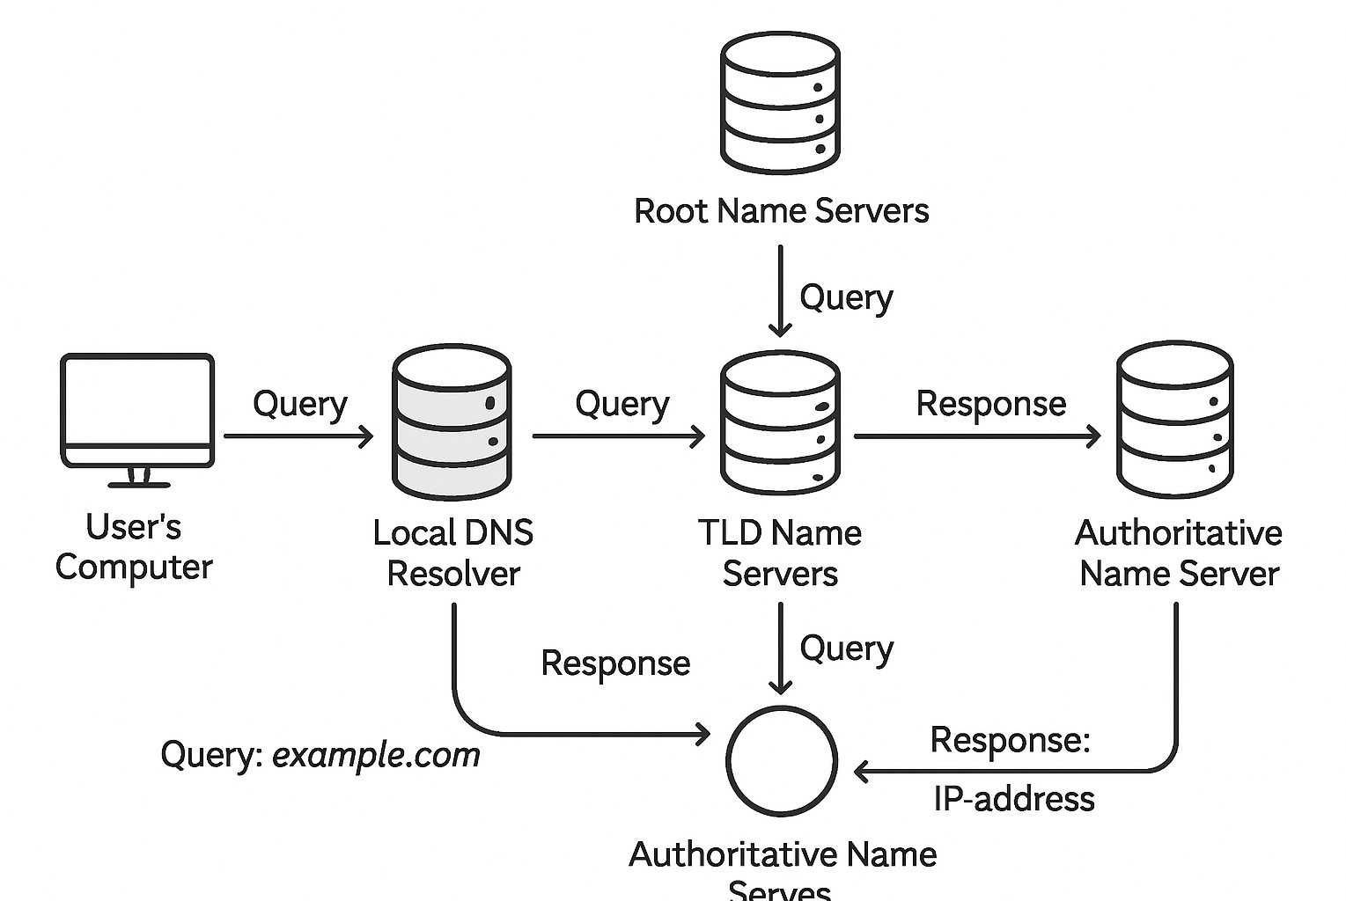

How DNS Works (Simplified)
When you type
www.example.com

into your browser, a series of steps occur:

  - Your computer checks its local DNS cache.
  - If not found, it queries a recursive DNS resolver (often provided by your ISP).
  - The recursive resolver queries a root name server.
  - The root name server directs it to the Top-Level Domain (TLD) name server
(e.g., for .com ).
  - The TLD name server directs it to the authoritative name server for
.
example.com
  - The authoritative name server provides the IP address for .
www.example.com
  - The recursive resolver sends the IP address back to your computer.
  - Your computer connects to the IP address.

DNS Records
Record Type | Description
A | Maps domain to IPv4 address
AAAA | Maps domain to IPv6 address
CNAME | Alias of another domain
MX | Mail server information
NS | Name server for domain
PTR | Reverse DNS lookup
SOA | Start of Authority
TXT | Stores text information

DNS uses port 53:
- UDP for normal queries
- TCP for zone transfers and large responses

SESSION 6: DHCP
Introduction to DHCP
Dynamic Host Configuration Protocol (DHCP) is an Application Layer protocol used to automatically assign IP configuration parameters to network devices. It eliminates the need for manual IP configuration.
- Dynamic Address Allocation DHCP has a second database with a pool of available IP addresses. This second database makes DHCP dynamic. When a DHCP client requests a temporary IP address, the DHCP server goes to the pool of available (unused) IP addresses and assigns an IP address for a negotiable period of time.

- When a DHCP client sends a DHCP request to a DHCP server, the server first checks its static database. If an entry with the requested physical address exists in the static database, the permanent IP address of the client is returned.
- On the other hand, if the entry does not exist in the static database, the server selects an IP address from the available pool, assigns the address to the client, and adds the entry to the dynamic database.
- The dynamic aspect of DHCP is needed when a host moves from network to network or is connected and disconnected from a network (as is a subscriber to a s rvice provider).
- DHCP provides temporary IP addresses for a limited time. The addresses assigned from the pool are temporary addresses.
- The DHCP server issues a lease for a specific time. When the lease expires, the client must either stop using the IP address or renew the lease.
- The server has the option to agree or disagree with the renewal. If the server disagrees, the client stops using the address.

DHCP provides:
- IP address
- Subnet mask
- Default gateway
- DNS server information
- Lease duration
DHCP in OSI Model
- Layer: Application Layer (Layer 7)
- Transport Protocol: UDP
- Ports:
  - Client → UDP port 68
  - Server → UDP port 67
DHCP Components
DHCP Client
- Any device requesting IP configuration
- Example: PC, laptop, mobile, printer
DHCP Server
- Assigns IP addresses and network parameters
- Maintains IP address pool (scope)
DHCP Relay Agent
- Forwards DHCP messages across different networks
- Used when DHCP server is on another subnet.

How DHCP Works (DORA Process)
The DHCP process assigns IP addresses to clients using four main steps, commonly remembered by the acronym DORA:
- Discover
When a client connects to a network, it does not have an IP address. The client broadcasts a DHCPDISCOVER message to locate available DHCP servers on the network.
- Offer
DHCP servers that receive the discover message respond with a DHCPOFFER message. This message contains an available IP address along with other configuration details such as subnet mask, default gateway, DNS server, and lease time.
- Request
The client selects one of the received offers and broadcasts a DHCPREQUEST message, formally requesting the offered IP address and notifying other servers to withdraw their offers.
- Acknowledge
The selected DHCP server sends a DHCPACK message, confirming the IP address assignment and providing the complete network configuration details.
This process enables automatic and efficient IP address assignment in a network.
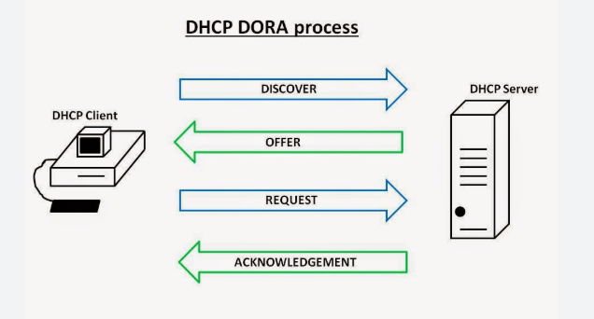

SESSION 7: NAT (Network Address Translation)
Network Address Translation (NAT) allows multiple devices in a private network to access the internet using a single public IP address. It helps conserve IPv4 addresses and hides internal systems for added security.
- Translates private IPs to public IPs and vice versa.
- Prevents IPv4 address exhaustion
- Adds security by masking internal devices
- Allows thousands of devices to share one public IP
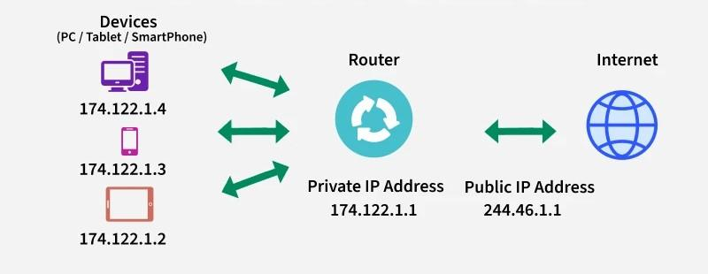Network Address Translation
Note: IPv4 provides only 2³² (about 4.3 billion) addresses, which is insufficient considering the massive number of devices connected to the Internet. NAT prevents IP exhaustion by enabling thousands of private devices to share a limited number of public IP addresses.
Working of NAT
This explains how NAT functions:
- A device sends a request → reaches the NAT-enabled router.
- Router replaces the private IP with its public IP and assigns a unique port.
- NAT stores this mapping in the NAT table.
- When the server responds, NAT uses the stored entry to send the packet to the correct internal device.
Types of NAT
There are three types of NAT:
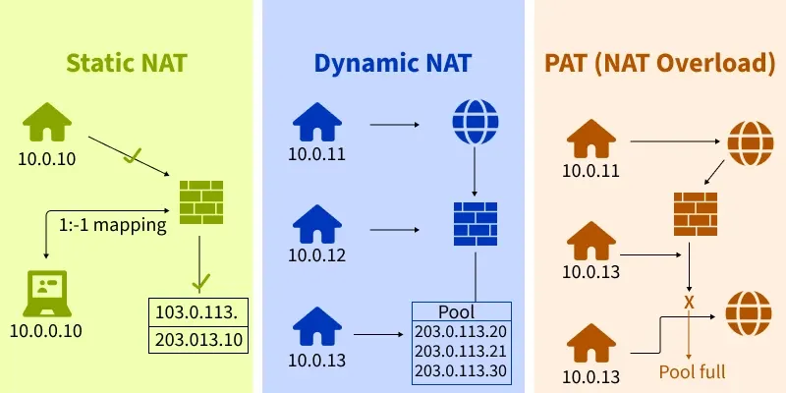
Types of NAT
1. Static NAT
- Maps one private IP to one public IP (one - to - one mapping).
- Commonly used in hosting, but not cost - effective for large organizations since each device requires a public IP.
2. Dynamic NAT
- Maps private IPs to public IPs from a predefined pool.
- If the pool is exhausted, additional requests are dropped.
- Suitable for networks with a limited number of users but still costly.
3. Port Address Translation (PAT)
- Also called NAT Overload.
- Multiple private IPs share a single public IP, with unique port numbers distinguishing traffic.
- Most widely used because it’s cost - effective and supports thousands of users with a single public IP.

SESSION 8: TCP and UDP

Transmission Control Protocol (TCP)
Transmission Control Protocol (TCP) is a connection-oriented, reliable transport layer protocol used to ensure accurate and ordered delivery of data between applications.
Key Features of TCP
- Establishes a connection using a three-way handshake
- Provides reliable data transfer
- Ensures in-order delivery of data
- Uses acknowledgements and retransmissions
- Supports flow control using sliding window
- Implements congestion control
- Higher overhead due to reliability mechanisms
TCP Connection Establishment (Three-Way Handshake)
- SYN → Client requests connection
- SYN-ACK → Server acknowledges
- ACK → Connection established
Applications Using TCP
- HTTP / HTTPS
- FTP
- SMTP
- POP3 / IMAP
- SSH

User Datagram Protocol (UDP)
User Datagram Protocol (UDP) is a connectionless, unreliable transport layer protocol designed for fast data transmission with minimal overhead.
Key Features of UDP
- No connection establishment
- No guarantee of delivery or order
- No acknowledgements or retransmissions
- No flow or congestion control
- Low latency and minimal overhead
- Suitable for real-time applications
Applications Using UDP
- Video streaming
- Online gaming
- VoIP
- DNS
- DHCP

Differences Between TCP and UDP
Feature | TCP | UDP
Connection type | Connection-oriented | Connectionless
Reliability | Reliable | Unreliable
Data delivery | Ordered | Unordered
Error control | Yes | No
Flow control | Yes | No
Congestion control | Yes | No
Speed | Slower | Faster
Overhead | High | Low
Header size | 20–60 bytes | 8 bytes
Use case | Data accuracy | Real-time data

When to Use TCP vs UDP
- Use TCP when accuracy and reliability are critical (file transfer, emails, web pages).
- Use UDP when speed and low latency are more important than reliability (live streaming, gaming).

One-Line Difference:
TCP provides reliable, ordered, and error-checked delivery of data, whereas UDP provides fast, connectionless data transmission without reliability guarantees.

SESSION 9: CSMA
Carrier Sense Multiple Access (CSMA) protocols manage how multiple devices share a single communication medium. Both variants follow the "Listen Before Talk" principle, where a device senses the channel for activity before attempting to transmit.
CSMA/CD (Collision Detection)
Used primarily in wired Ethernet networks (IEEE 802.3), CSMA/CD manages access by detecting collisions after they happen.
- How it works: A device listens to the cable; if it's idle, it sends data. While transmitting, it continues to monitor the wire for other signals.
- Collision Handling: If a collision is detected (signal voltage rises), the device stops transmitting immediately, sends a jam signal to notify others, and waits a random amount of time (binary exponential backoff) before retrying.
- Modern Status: Mostly obsolete in modern networks because Ethernet switches and full-duplex communication create dedicated collision-free paths.
CSMA/CA (Collision Avoidance)
Used in wireless Wi-Fi networks (IEEE 802.11) because wireless hardware cannot reliably detect collisions while transmitting due to signal strength differences.
- How it works: Before sending data, a device senses the medium. If idle, it waits for a short period called Interframe Space (IFS) and then a random backoff period before transmitting to reduce the chance of simultaneous starts.
- Collision Handling: It focuses on prevention. It often uses an optional handshake mechanism—Request to Send (RTS) and Clear to Send (CTS)—to reserve the channel and solve the "hidden node" problem where devices can't see each other but can both see the access point.
- Reliability: Since it cannot detect collisions, it relies on an Acknowledgment (ACK) from the receiver. If no ACK is received, it assumes a collision occurred and retransmits.
Key Differences Summary
Feature | CSMA/CD (Wired) | CSMA/CA (Wireless)
Standard | IEEE 802.3 (Ethernet) | IEEE 802.11 (Wi-Fi)
Goal | Detect and recover from collisions | Avoid collisions before they occur
Action | Effective after a collision | Effective before a collision
Mechanism | Jam signal + Random backoff | RTS/CTS + ACK + Random backoff
Overhead | Low overhead | High overhead (extra control frames)

SESSION 10: HTTP and HTTPS
Introduction
HTTP (HyperText Transfer Protocol) and HTTPS (HyperText Transfer Protocol Secure) are Application Layer (Layer 7) protocols used for communication between web clients (browsers) and web servers. They follow a request–response model.

HTTP (HyperText Transfer Protocol)
Features:
- Transfers web pages, images, and data
- Stateless protocol
- Uses TCP
- Default port: 80
- Data transmitted in plain text

HTTPS (HTTP Secure)
Features:
- Secure version of HTTP
- Uses SSL/TLS encryption
- Default port: 443
- Provides confidentiality, integrity, and authentication
- Prevents eavesdropping and tampering

Differences Between HTTP and HTTPS
Feature | HTTP | HTTPS
Security | Not secure | Secure (Encrypted)
Encryption | No | Yes (SSL/TLS)
Port Number | 80 | 443
Data Protection | None | Confidentiality & integrity
URL Prefix | http:// | https://
Certificate | Not required | Required (SSL certificate)

Basic Working of Web Client and Server
Step-by-Step Process:
1. URL Entry
User enters a URL in the web browser (client).
2. DNS Resolution
Browser queries DNS to get the IP address of the web server.
3. TCP Connection
Client establishes a TCP connection with the server.
- HTTPS additionally performs TLS handshake.
4. HTTP/HTTPS Request
Client sends an HTTP request (GET/POST).
5. Server Processing
Server processes the request and fetches required resources.
6. HTTP/HTTPS Response
Server sends a response with status code (200, 404, etc.).
7. Rendering
Browser renders the received content.

Summary
HTTP enables web communication but lacks security. HTTPS enhances HTTP by using SSL/TLS encryption, ensuring secure and authenticated data transfer. Web communication follows a request–response model between client and server.
SESSION 11: SOCKETS
1. Introduction to Socket Programming
Socket programming enables communication between two systems (client and server) over a network. A socket acts as an endpoint for sending and receiving data.

2. What is a Socket?
A socket is a software structure that allows a program to connect to another program on a network.
Each socket is bound to:
- An IP Address
- A Port Number
Analogy: A socket is like a telephone jack that allows two devices to connect and communicate.
3. Types of Sockets
Type | Description | Protocol
Stream Sockets | Provide reliable, two-way, connection-based communication. | TCP
Datagram Sockets | Provide fast, unreliable, connectionless communication. | UDP

4. Client-Server Model
In most network communications, one program acts as the server and waits for connections, while another acts as the client and initiates the connection.
Server Responsibilities:
- Wait for client requests
- Process request
- Send response
Client Responsibilities:
- Initiate connection
- Send request
- Receive response

5. Socket API Functions
For TCP (Stream Socket)
Server Side (C/POSIX):
- socket() – Create socket
- bind() – Bind socket to IP and port
- listen() – Listen for incoming connections
- accept() – Accept client connection
- read() / recv() – Receive data
- write() / send() – Send data
- close() – Close the socket
Client Side (C/POSIX):
- socket() – Create socket
- connect() – Connect to server
- read() / recv() – Receive data
- write() / send() – Send data
- close() – Close the socket
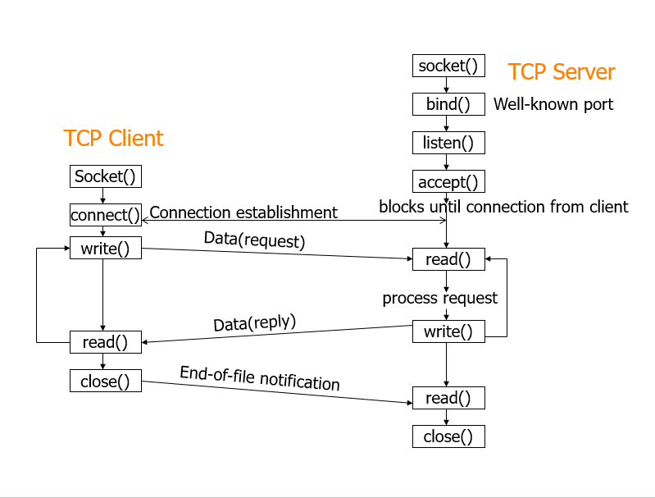 Socket Programming in Java (TCP Example)
Server.java
import java.io.*;
import java.net.*;

public class Server {
public static void main(String[] args) throws IOException {
ServerSocket serverSocket = new ServerSocket(8080);
Socket clientSocket = serverSocket.accept();

BufferedReader in = new BufferedReader(new InputStreamReader(clientSocket.getInputStream()));
PrintWriter out = new PrintWriter(clientSocket.getOutputStream(), true);

String msg = in.readLine();
System.out.println("Client: " + msg);
out.println("Hello from Server");

clientSocket.close();
serverSocket.close();
}
}
Client.java
java
CopyEdit
import java.io.*;
import java.net.*;

public class Client {
public static void main(String[] args) throws IOException {
Socket socket = new Socket("localhost", 8080);

BufferedReader in = new BufferedReader(new InputStreamReader(socket.getInputStream()));
PrintWriter out = new PrintWriter(socket.getOutputStream(), true);

out.println("Hello Server");
String response = in.readLine();
System.out.println("Server: " + response);

socket.close();
}
}

8. UDP Socket Programming
In UDP, there's no connection establishment. Messages (datagrams) are sent directly.
Important Functions:
- sendto()
- recvfrom()
UDP is faster but does not guarantee delivery.

SESSION 12: WEBSOCKETS
WebSockets enable real-time, two-way communication between a client (browser) and a server over a single, persistent connection.
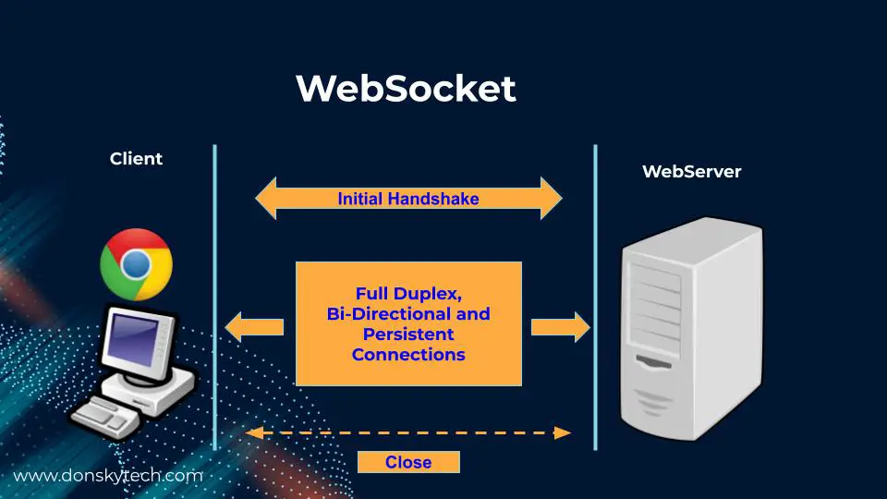

1. Key Features
- Persistent Connection: Once established, the connection stays open
- Full-Duplex: Both client and server can send/receive data simultaneously
- Low Latency: Near-instant communication (no HTTP overhead)
- Cross-Origin Support: Works across different domains (with proper CORS)

2. Connection Lifecycle
- Handshake: Client sends HTTP upgrade request → Server accepts
- Open: Connection established (readyState = 1)
- Data Exchange: Messages flow bidirectionally
- Close: Either side can terminate the connection
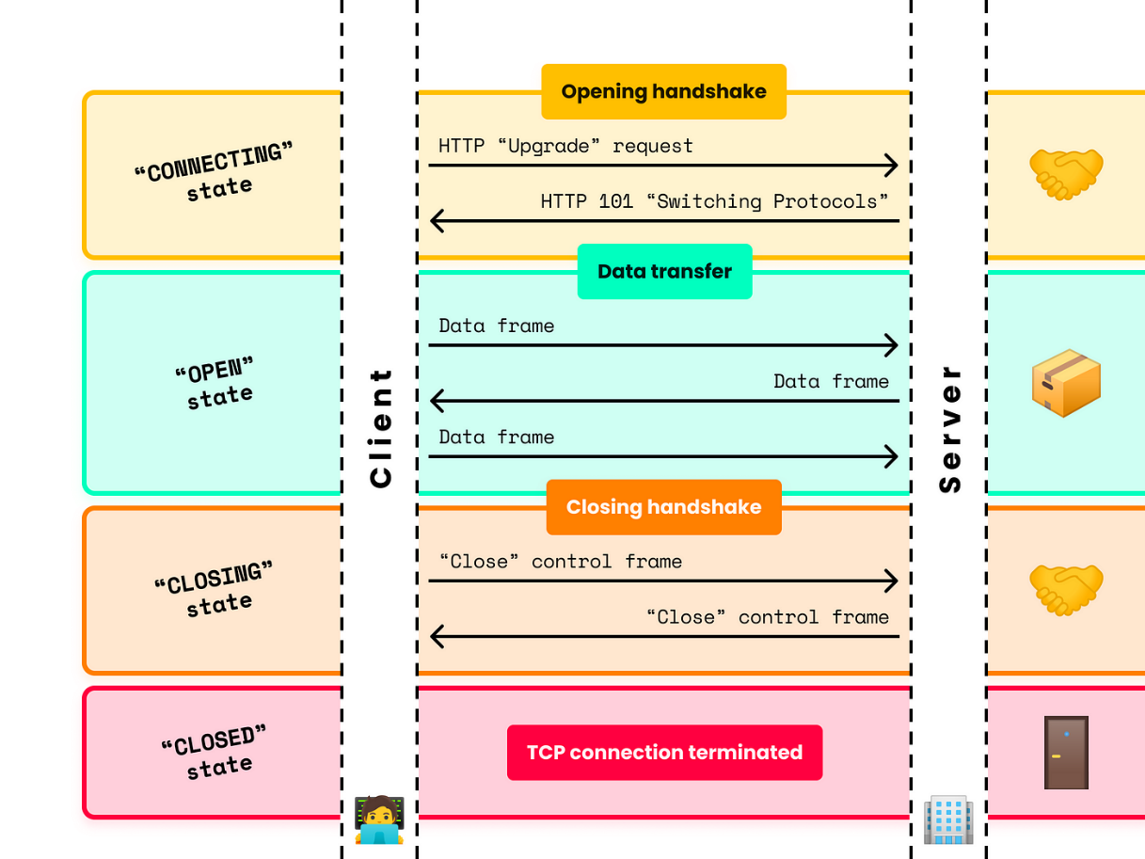

3. Client-Side Basics (Browser)
- Create Connection: new WebSocket(url)
- Events:
  - onopen: Connection established
  - onmessage: Data received from server
  - onerror: Connection error occurred
  - onclose: Connection closed
- Methods:
  - send(data): Send data to server
  - close(): Close connection

4. Data Types Supported
- Text: Strings, JSON (most common)
- Binary: Blobs, ArrayBuffers (for files, images)

5. Simple Real-World Use Cases
- Live chat applications
- Real-time notifications
- Multiplayer games
- Live sports updates
- Collaborative tools (like Google Docs)
- Financial tickers

6. Key Advantages Over HTTP
- No Polling: Server can push data instantly
- Less Overhead: No repeated headers/connections
- True Real-Time: Suitable for low-latency applications.
- WebSocket vs HTTP
Feature | HTTP | WebSocket
Connection | Short-lived | Persistent
Communication | Request-Response | Full-duplex
Headers | Every request | Only during handshake
Latency | Higher | Lower
Use Case | Traditional web pages | Real-time applications

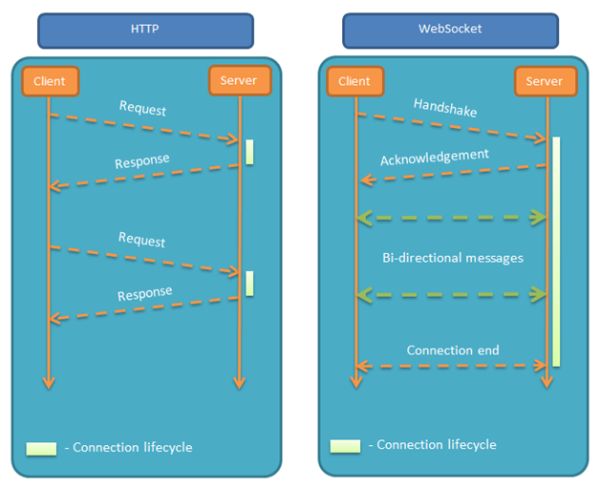

7. Important Notes
- Always use wss:// (not ws://) in production for security
- Handle reconnections (networks can drop)
- Implement heartbeats to keep connection alive
- Validate all incoming data (security)
In essence: WebSockets provide a direct "phone line" between client and server instead of the "walkie-talkie" model of HTTP requests.

